**Usages of Global Parameter in ADF:**

1 If same parameters and values used in more than one pipeline then global parameter comes into picture. It need to define once and can be reused crossed ADF.

2. Reusability purpose

3. Different environment have different values for same parameter

**Examples:**

1. Rest API URL are same and used by more than one pipeline. In this case, we can apply Global Parameter concept.
2. More than one pipeline, used same parameter values e.g root folder
3. Sending an email, from and to email parameters or message body.

**What is Global Parameters?**

Global parameters are constants across a data factory that can be consumed by a pipeline in any expression. They're useful when you have multiple pipelines with identical parameter names and values.

**Creating global parameters:-**

1. **ADF** portal => **Manage** section => **Global Parameter** Section =>**New**
2. Enter a name, select a data type, and specify the value of your parameter.
3. **Editing global parameters.** You can edit Parameter by clicking on edit button. Also, it can be deleted from same screen

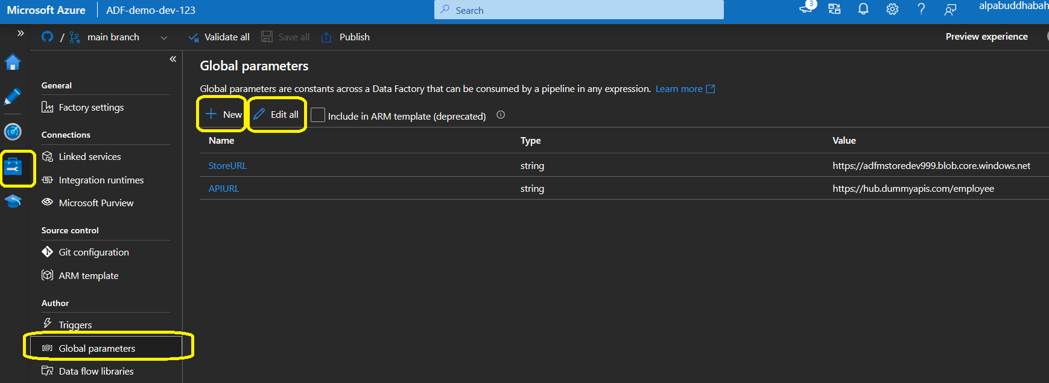

Following data types available at the moment to set parameters.

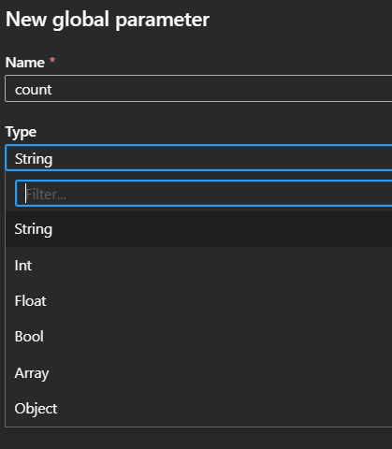

**Consuming global parameters: -**

Global parameters can be used in any [pipeline expression](https://docs.microsoft.com/en-us/azure/data-factory/control-flow-expression-language-functions). If a pipeline is referencing another resource such as a dataset or data flow, you can pass down the global parameter value via that resource's parameters.

**Access Global parameters:**

pipeline().**globalParameters.**<parameterName>.

e.g - pipeline().**globalParameters.**SFURL

**Pipeline: PL_GLOBAL_PARAM**

